Table of Contents

Table of Figures 2

1) What is web? 2

2) What is W3C? 2

3) What is InterNet? 2

I. Comparing WAN Vs. LAN Vs. MAN 3

4) HTML 3

5) Some question and Answer 4

II. Difference between Markup and Programming language? 4

III. Difference between Dynamic and static website? 4

IV. Why markup language is so dangerous? 5

6) Features of HTML 5

7) Disadvantage of HTML 5

8) History of HTML 5

9) What is tag? 5

a) Paired tags 6

b) Non Paired tags 6

10) Basic Structure of HTML 6

11) Working with HTML 7

12) Comments 7

13) Section in HTML 7

I. Head section 7

14) Favicon 8

V. Code for favicon example 8

15) <meta/> tag 10

16) <style> 11

17) <script> 12

18) Complete code of some tags and command 13

19) Body Section 17

VI. Color codes 17

20) HTML 5 special character(Entities) 18

21) HTML Headings 19

22) HTML Paragraph(<p> tag) 20

23) Line Brake(<br> tag) 21

24) Non-Breaking Space (&nbsp;) 21

25) HTML Horizontal rule(<hr> tag) 21

26) User Inputs 22

VII. HTML forms(<form> tag) 22

# Table of Figures

**Figure 1 Basic Html Structure** 7

Figure 2 code to use faviconwhen image in same folder 9

Figure 3 Favicon image 1 10

Figure 4 code of favicon when image is in different folder 10

Figure 5 style web page 12

Figure 6 style code 12

Figure 7 complete code web page 1 15

Figure 8 complete code part2 16

Figure 9 complete code 1 16

Figure 10 complete code web site 2 17

Figure 11 Enitities web site 18

Figure 12 Heading code snip 19

Figure 13 Heading Website view 19

Figure 14 Paragraph web snip 20

Figure 15 Paragraph code 20

Figure 16 hr tag code 21

Figure 17 hr tag website snipt 22

Figure 18 form web look 23

Figure 19 form code 23

Figure 20 textarea web snipt 24

Figure 21 dropdown list web snipt 27

Figure 22 radio web snipt 29

# What is web?

* Collection of e resources connected electronically.
* Father of web is **Tim Berners Lee**

# What is W3C?

* World Wide Web consortium.
* It is a organization to maintain web standards.
* It is founded by **Tim Berners Lee.**
* **1st October 1994 at MIT LCS (Masschussests institute of technology Laboratory of computer Science).**

# What is InterNet?

1. International Network
   * + - * PAN (personal area network)
         * Lan(Local area network)
         * WAN (wide area Network)
         * Internet

2. Father of the internet is **Dr. Vint Cerf.**

## Comparing WAN Vs. LAN Vs. MAN

|  |  |  |
| --- | --- | --- |
| WAN | LAN | MAN |
| Wide Area Network | Local Area Network | Metropolitan Area Network |
| A WAN will typically cover a larger area geographically, such as a continent, a state or a country. | A LAN connects computers within a small and specific area geographically. | A MAN is confined to a specific town,  city or region. It covers a larger area  than a LAN but a smaller area than a  WAN. |
| For data transfer, there is low bandwidth. | For data transfer, there is high bandwidth. | For data transfer, there is a moderate  bandwidth. |
| It will typically have a distributed ownership model. | It is typically owned by an individual or an organization. | It can be owned publicly or privately. |
| A WAN network will have a larger coverage area that can range up to 100,000 KM and in some cases, stretches globally or over international borders. | A LAN network is limited to between 100-1000 meters coverage. | A MAN network is will usually stretch  up to an area of 100 KM. |
| It costs more to set-up a WAN than a LAN or a MAN. | It has a low cost of set-up. | It has a moderate cost of set-up. |
| With a WAN, you can get lower speeds of data transfer of 10-20 Mbps. | With a LAN, you can get higher speeds of data transfer with 10/100/1000 Mbps Ethernet (high speed). | With a MAN, you can get speeds of data  transfer up to 100 Mbps. |

# HTML

* **Hypertext Markup Language**
* It is a standard markup language used to create static web pages.

# Some question and Answer

## Difference between Markup and Programming language?

The **main difference** between markup language and programming language is that **a markup language defines a set of rules for encoding documents in a format that is both human-readable and machine-readable while a programming language provides a set of commands and syntax that can be used to write computer programs which are understood by the computer.**

A markup language is a type of language used to annotate text and embed tags in accurately styled electronic documents, irrespective of computer platforms, [operating systems](https://pediaa.com/difference-between-operating-system-and-application-software/#Operating%20System), applications or programs.  However, a programming language is a language that provides a set of rules, syntax, and commands to write computer programs that implements [algorithms](https://pediaa.com/difference-between-algorithm-and-pseudocode/#Algorithm).

## Difference between Dynamic and static website?

|  |  |
| --- | --- |
| In static web pages, Pages will remain same until someone changes it manually. | In dynamic web pages, Content of pages are different for different visitors. |
| 2. | Static Web Pages are simple in terms of complexity. | Dynamic web pages are complicated. |
| 3. | In static web pages, Information are change rarely. | In dynamic web page, Information are change frequently. |
| 4. | Static Web Page takes less time for loading than dynamic web page. | Dynamic web page takes more time for loading. |
| 5. | In Static Web Pages, database is not used. | In dynamic web pages, database is used. |
| 6. | Static web pages are written in languages such as: HTML, JavaScript, CSS, etc. | Dynamic web pages are written in languages such as: CGI, AJAX, ASP, ASP.NET, etc. |
| 7. | Static web pages does not contain any application program . | Dynamic web pages contains application program for different services. |
| 8. | Static web pages require less work and cost in designing them. | Dynamic web pages require comparatively more work and cost in designing them. |

## Why markup language is so dangerous?

Because we cannot find easily errors in markup language.

# Features of HTML

* HTML is highly flexible and simple
* HTML is supported on almost every web browser.
* HTML is user friendly.

# Disadvantage of HTML

* It can create only static plain pages
* We need to write a lot of code for making simple page
* Security features of html are not good.

# History of HTML

* 1989 GML( Generalized Markup Language)
* 1991 SGML( Standard GML)
* 1994 HTML
* 2008 HTML5
* 2016 HTML 5.1

Note:- HTML is completely enclosed in tags.

# What is tag?

* Text placed between ‘<’ and ‘>’ is called as tag.
* E.G. <html>
* Types are classified into two types
  + Paired tags
  + Non-Paired tags

### Paired tags

The tags that have both opening and closing tags are called as paired tags.

E.g. <html>

…

…

…

</html>

<body>

…

…

…

</body>

Note:-The closing tag started with ‘/’.

### Non Paired tags

* That tags that have only opening tag but no closing tag are called as non-paired tag.
* These tags are also called as
  + Self-closed tags
  + Forcefully closed tags
  + Empty tags
  + Singular tags

e.g

<br> or <br /> Break Tag(line Break)

<hr> or <hr /> Horizontal Rule(Horizontal Line)

<img> image tag

# Basic Structure of HTML

<html>

<head>

<title>….</title>

</head>

<body>

</body>

</html>

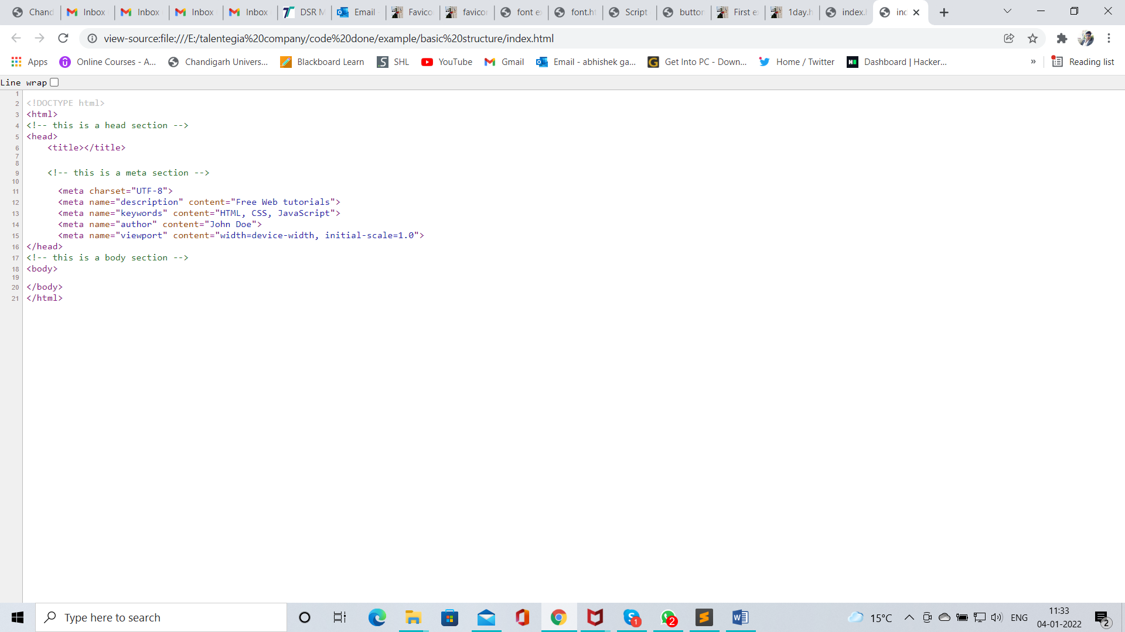

**Figure 1 Basic Html Structure**

# 

# Working with HTML

* Open any text editor e.g. notepad, notepad++, sublime text, etc.
* Save this file with any name and extension ‘.html’
* Run above file in any web browser e.g. MS internet explorer, MS edge, Google chrome, MFF, Safari, Opera, UCB etc.

Note :- HTML is case insensitive means A and a are same.

# Comments

* Comments provides additional information about that code.
* Comments are not displayed on web page.
* <!-- This is comment -->

# Section in HTML

* Head section
* Body section
* <!doctype html>

It is used to tell web browser that <> are tags.

## Head section

* This section contains root element as <head> tag.
* It is a paired tag.
* This tag contain following tags
  + <title> document title

<link /> link to external document

It is a non paired tags

* + Attributes = href,rel,type e.g. Displaying favicon
  + <meta /> meta description
  + <style> used for styling
  + <script> used to provide script

# Favicon

* it is a graphical image associates with title of web page
* its size should be 16 * 16 px or 32*32 px.
* **<link** rel="shortcut icon" href="favicon.ico" type="image/x-icon"**>**
* Sites for favicon image 1. Clipart 2. Favicon
* Code of path of an image which is saved in different folder
* <link rel="shortcut icon" href="<file:///E:\PICTURES\20181119_120136.jpg>" type="image/x-icon">

## Code for favicon example

<!DOCTYPE html>

<html>

<head>

<title>Favicon Example</title>

<link rel="shortcut icon" href="a.png" type="image/x-icon">

</head>

<body>

hello

<h1>Example of favicon command</h1>

</body>

</html>

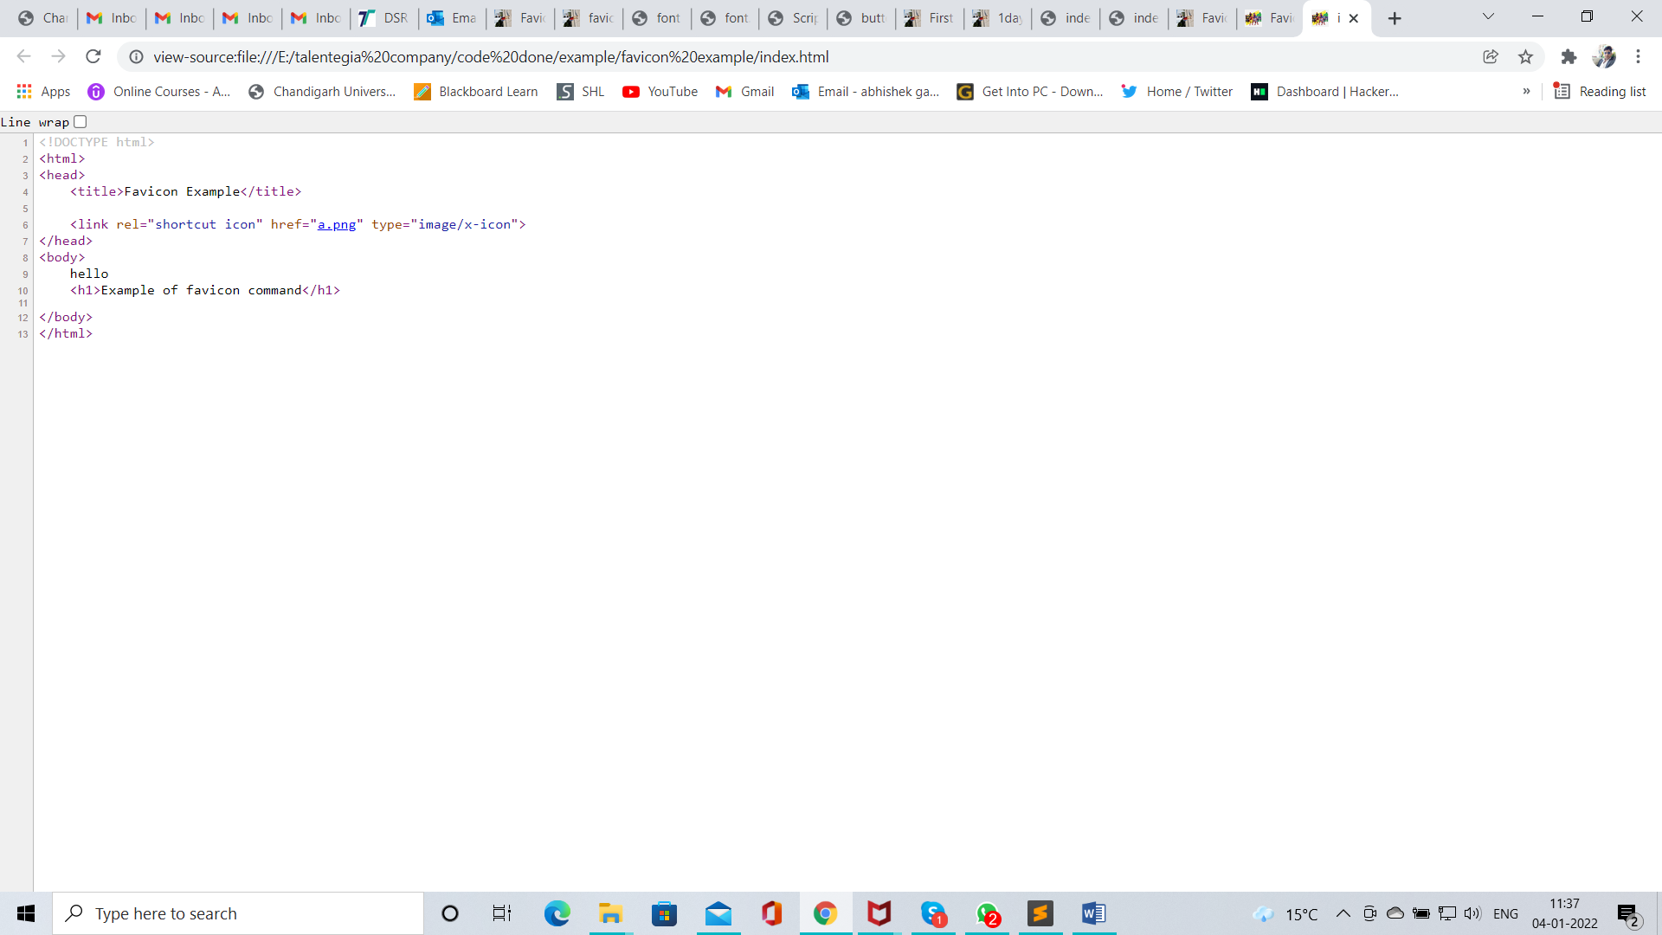

Figure 2 code to use faviconwhen image in same folder

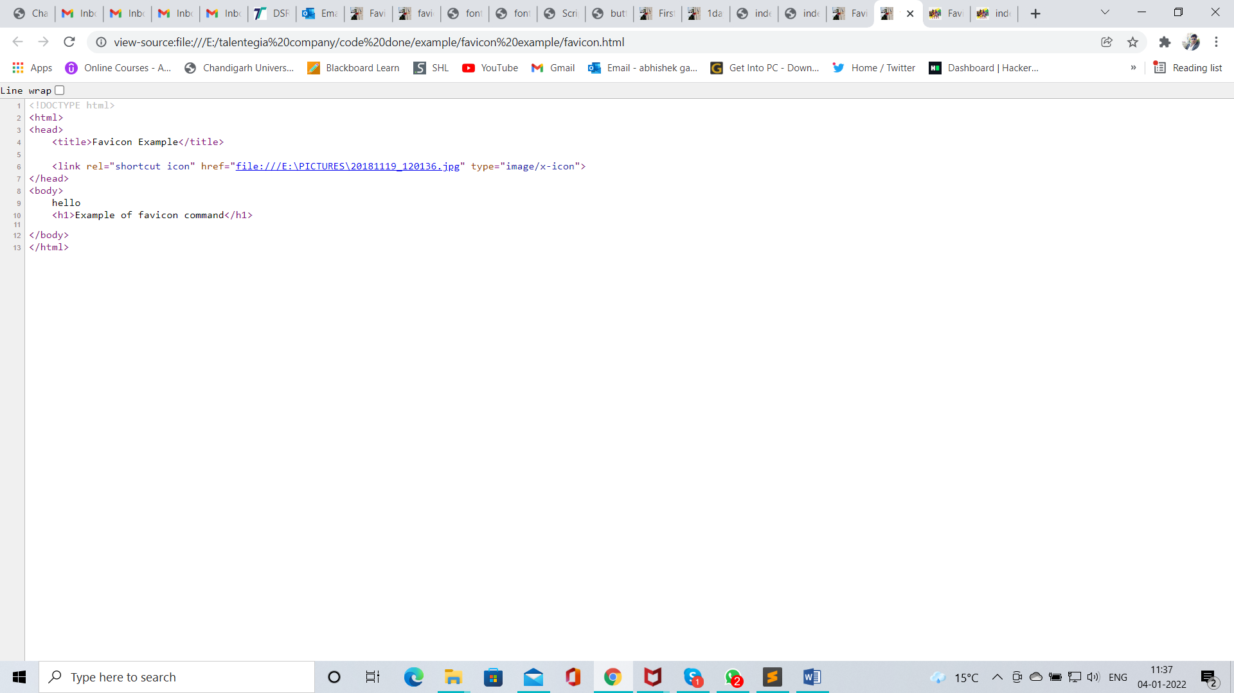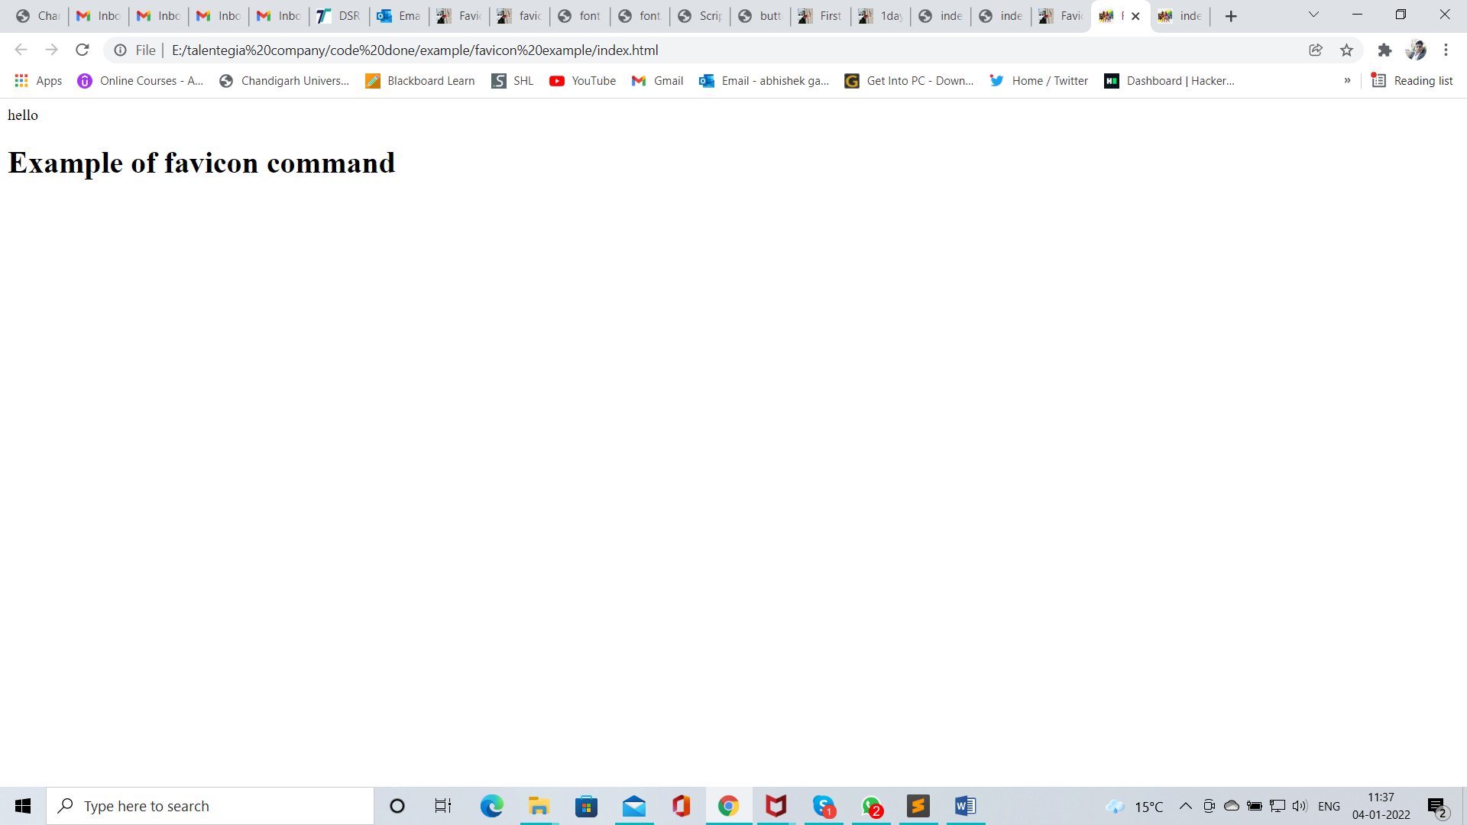

Figure 3 Favicon image 1

Figure 4 code of favicon when image is in different folder

# <meta/> tag

* Meta data is data about data.
* <meta/> tag provides metadata about html document
* Metadata is not displayed on web page but it can be machine parsable (understandable).
* Meta Attributes

1. Meta keywords
2. Meta description
3. Meta author
4. Meta title
5. Meta charset
6. Meta viewport

# <style>

* It is used to apply styles to html documents
* It is a paired tag.
* Code

<!DOCTYPE html>

<html>

<!-- this is a head section -->

<head>

<title>font example</title>

<style>

p{

color: red;

font-family: candara;

font-size: 50px;

}

body{

background-color: black;

}

h1{

color: black;

font-family: lucida calligraphy;

font-size: 120px;

text-shadow: 0px 0px 5px red;

}

</style>

</head>

<!-- this is a body section -->

<body>

<p>Wlecome</p>

<h1>Font example</h1>

</body>

</html>

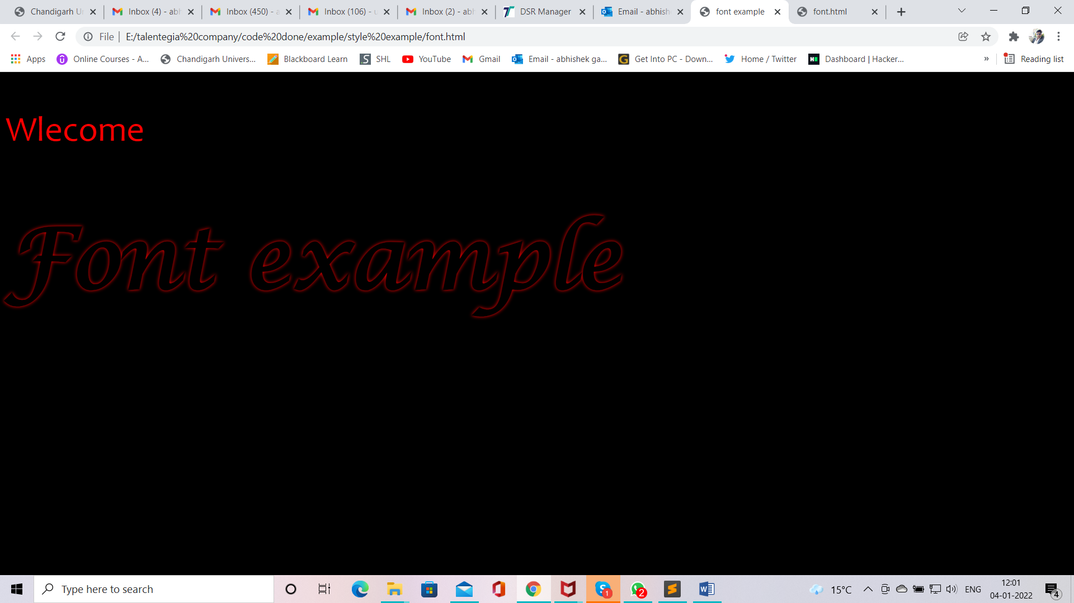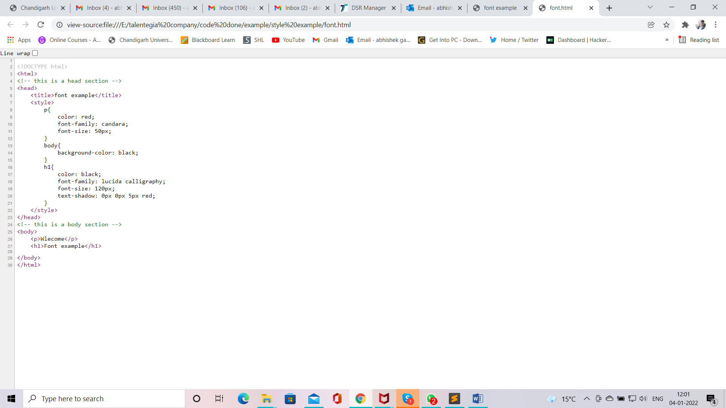

Figure 5 style web page

Figure 6 style code

# <script>

* It is a paired tag.
* It is used to apply script to html page.
* Code

<!DOCTYPE html>

<html>

<!-- this is a head section -->

<head>

<title>Script demo</title>

<script type="text/javascript" language="javascript">

function myAlert()

{

alert("button clicked")

}

</script>

</head>

<!-- this is a body section -->

<body>

<h1></h1>

<p></p>

<button on onclick="myAlert()">click me</button>

</body>

</html>

# Complete code of some tags and command

Like

1. provide heading
2. provide description
3. provide favicon
4. change button color
5. change button font color
6. change button font size
7. change background color
8. apply text shadow tag
9. also create button alert in JavaScript function

<!DOCTYPE html>

<html>

<!-- this is a head section -->

<head>

<title>First experiment</title>

<!-- this is a meta section -->

<meta charset="UTF-8">

<meta name="description" content="Web Tutorials">

<meta name="keywords" content="HTML, style, JavaScript">

<meta name="author" content="Abhishek">

<meta name="viewport" content="width=device-width, initial-scale=1.0">

<!-- this is a favicon section -->

<link rel="shortcut icon" href="file:///E:\PICTURES\20181119_120136.jpg" type="image/x-icon">

<!-- this is a javascript section section -->

<script type="text/javascript" language="javascript">

function myAlert()

{

alert("button clicked")

}

</script>

<!-- this is a style section -->

<style>

body{

background-color: #ADD8E6;

}

button{

color: red;

background-color: #FF00FF;

font-size: 20px;

margin-left: 50px;

}

h1{

text-align: center;

text-shadow: 0px 0px 5px red;

}

</style>

</head>

<!-- this is a body section -->

<body>

<h1>Welcome to First execution Project</h1>

<p>

Video provides a powerful way to help you prove your point. When you click Online Video, you can paste in the embed code for the video you want to add. You can also type a keyword to search online for the video that best fits your document.

To make your document look professionally produced, Word provides header, footer, cover page, and text box designs that complement each other. For example, you can add a matching cover page, header, and sidebar. Click Insert and then choose the elements you want from the different galleries.

Themes and styles also help keep your document coordinated. When you click Design and choose a new Theme, the pictures, charts, and SmartArt graphics change to match your new theme. When you apply styles, your headings change to match the new theme.

Save time in Word with new buttons that show up where you need them. To change the way a picture fits in your document, click it and a button for layout options appears next to it. When you work on a table, click where you want to add a row or a column, and then click the plus sign.

Reading is easier, too, in the new Reading view. You can collapse parts of the document and focus on the text you want. If you need to stop reading before you reach the end, Word remembers where you left off - even on another device.

</p>

<button on onclick="myAlert()">click me</button>

</body>

</html>

<!--

provide heading

provide description

provide favicon

change button color

chnage button font color

change button font size

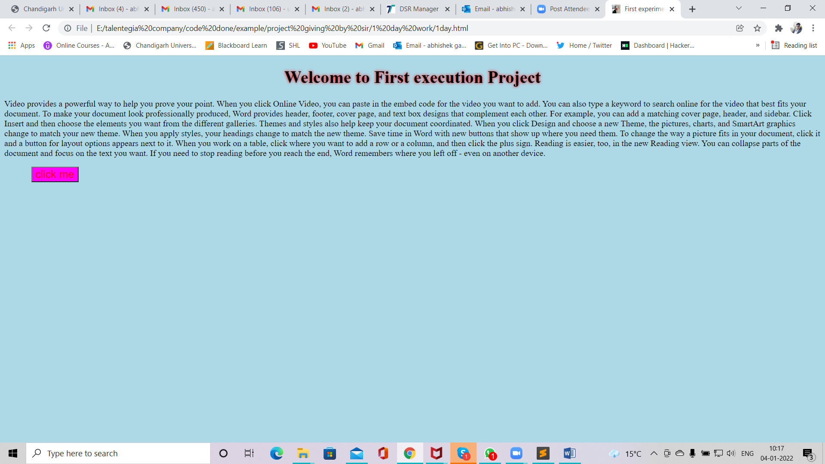 -->

Figure 7 complete code web page 1

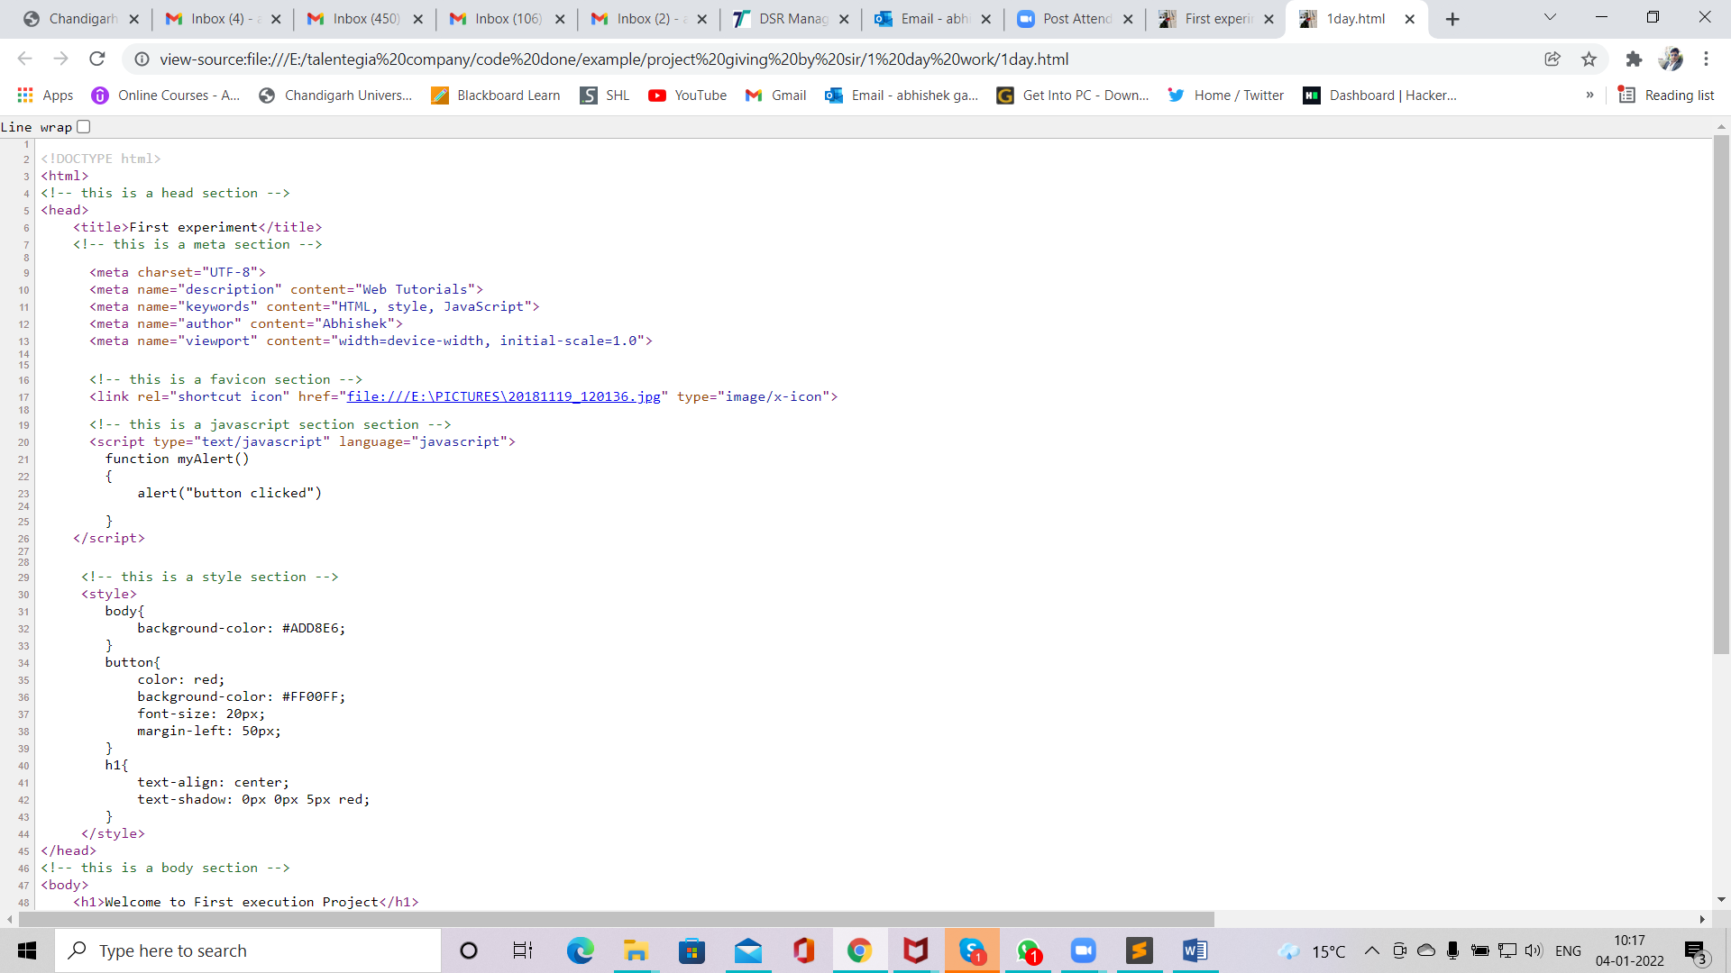

Figure 8 complete code part2

Figure 9 complete code 1

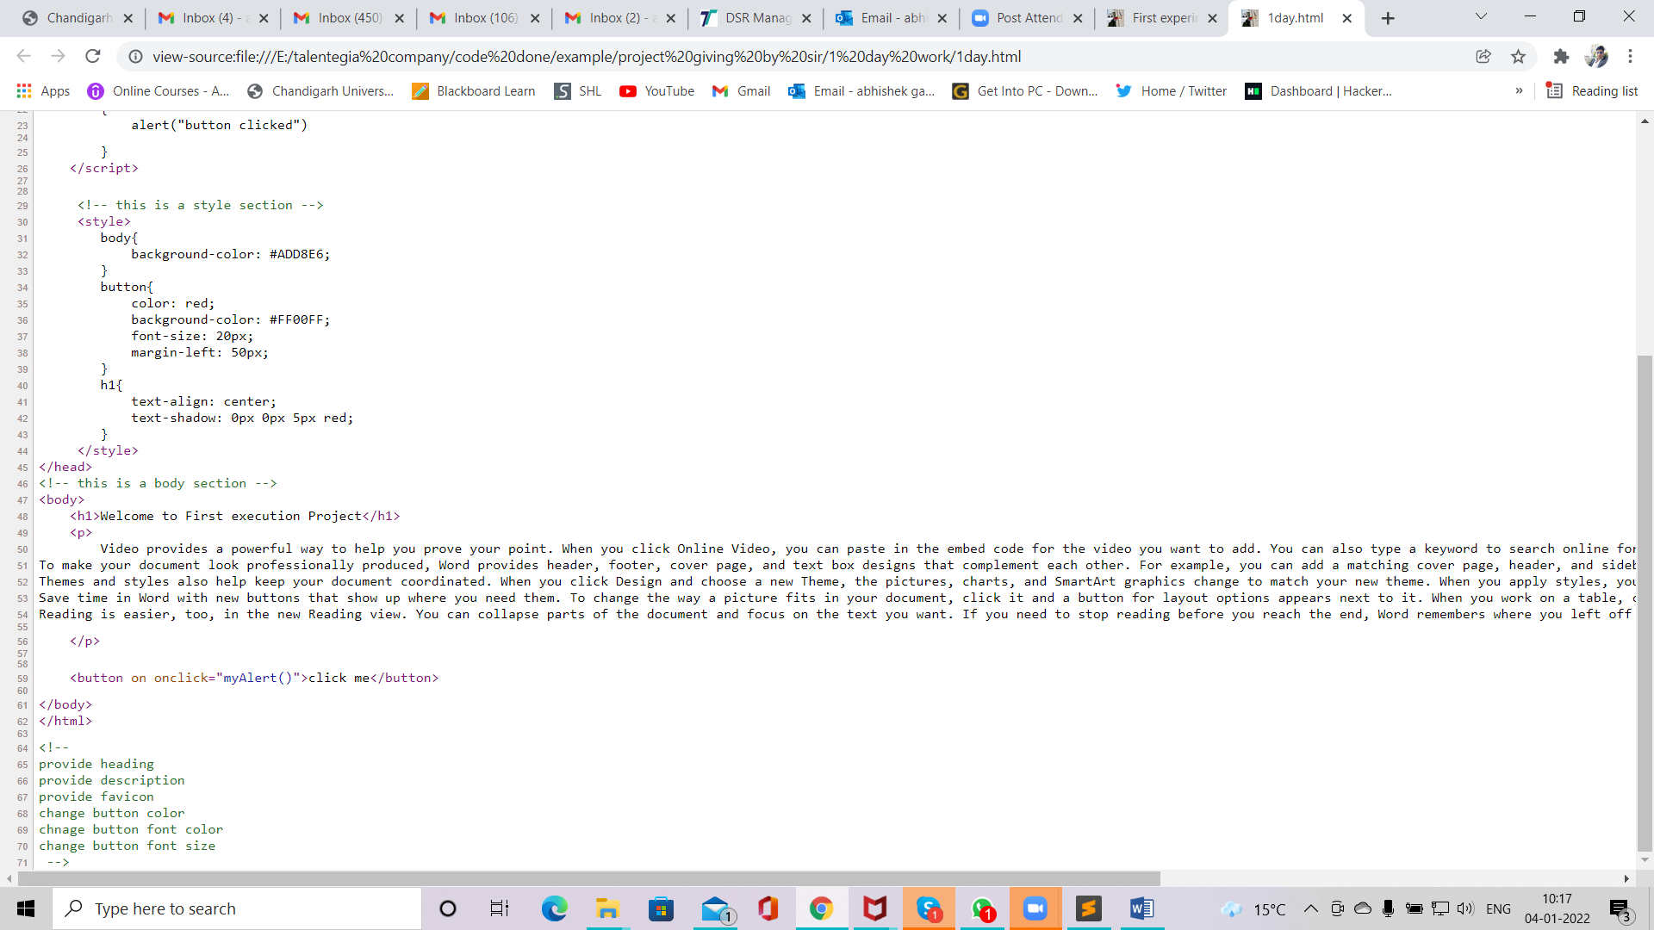

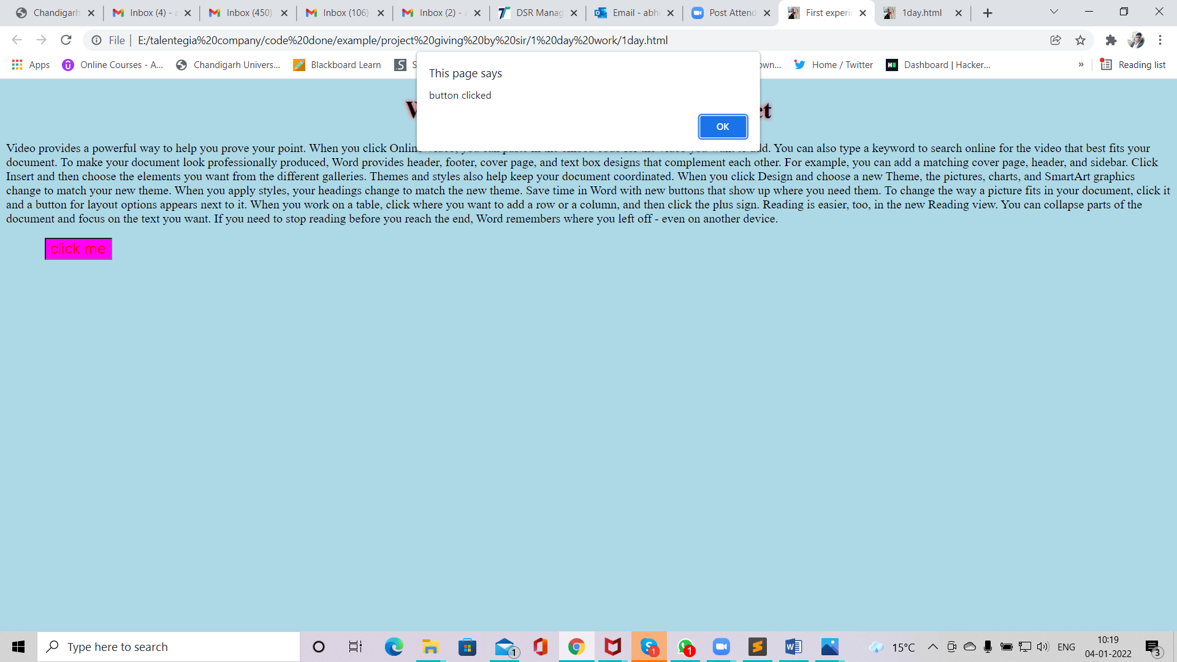

Figure 10 complete code web site 2

# Body Section

* It contains <body> tag as root elements
* This section contains contents of html document, such as text, hyperlinks, images, special characters, lists, forms etc.
* <body> is paired tag.

Attributes parameters

Background image path

Bgcolor color name/ code

Text color name/ code

## Color codes

* Html color are defined in 24bit RGB values.
* These values are represented in hexadecimal forms.
* Values start with #
* 0 is the lowest values.
* F is the largest/highest value

R G B color name color code

#FF FF FF WHITE #FFFFFF

#00 00 00 BLACK #000000

#FF 00 00 RED #FF0000

#00 FF 00 GREEN #00FF00

#00 00 FF BLUE #0000FF

# HTML 5 special character(Entities)

* Character entities can be typed as either numbered entity or named entity
* All entities begin with ‘&’ and end with ‘;’
* E.g. &copy; &reg; &trade;
* &#169; &#174; &#8482;
* Website link <http://www.columbia.edu/kermit/ucs2.html>
* But code should be in hexadecimal form

Code is

<!DOCTYPE html>

<html>

<!-- this is a head section -->

<head>

<title>Html enities</title>

<!-- this is a meta section -->

<meta charset="UTF-8">

<meta name="description" content="">

<meta name="keywords" content="">

<meta name="author" content="">

<meta name="viewport" content="width=device-width, initial-scale=1.0">

</head>

<!-- this is a body section -->

<body>

<p>&copy; &reg; &trade;</p>

<p>&#169; &#174; &#8482; &#2315; &#176;</p>

</body>

</html>

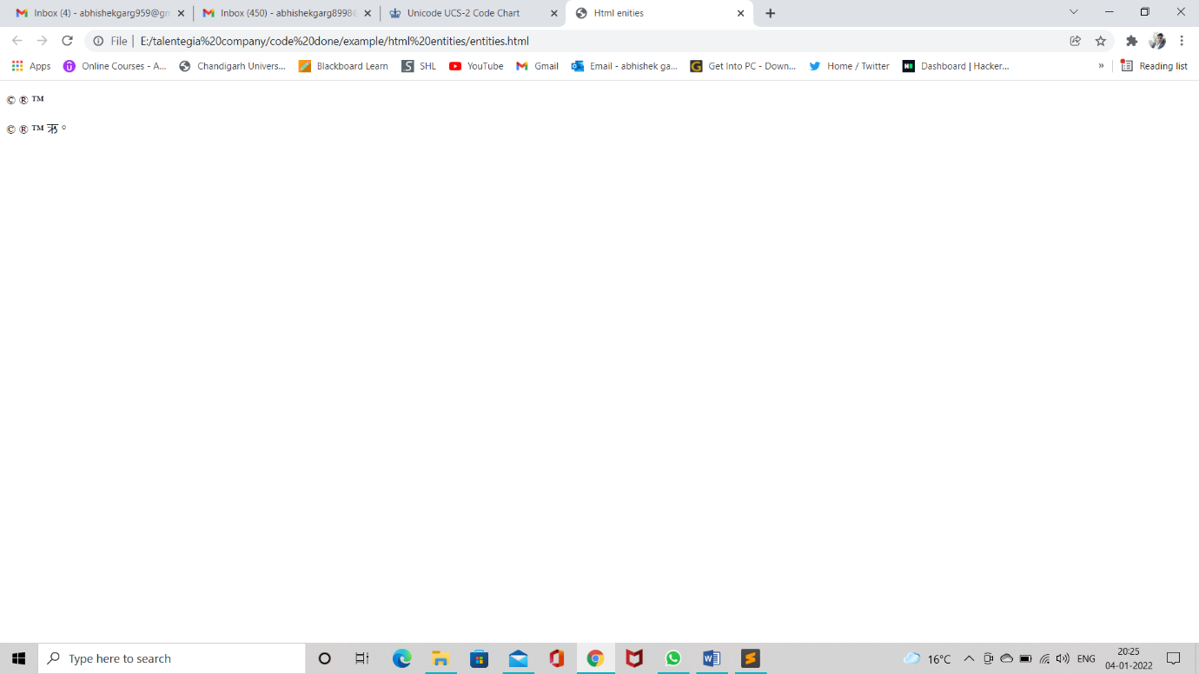

Figure 11 Enitities web site

# HTML Headings

* In HTML there are six type of heading tags.
* H1,H2,H3,H4,H5,H6
* All Headings tags are paired tags.

Attributes Parameters

Align left, center, right

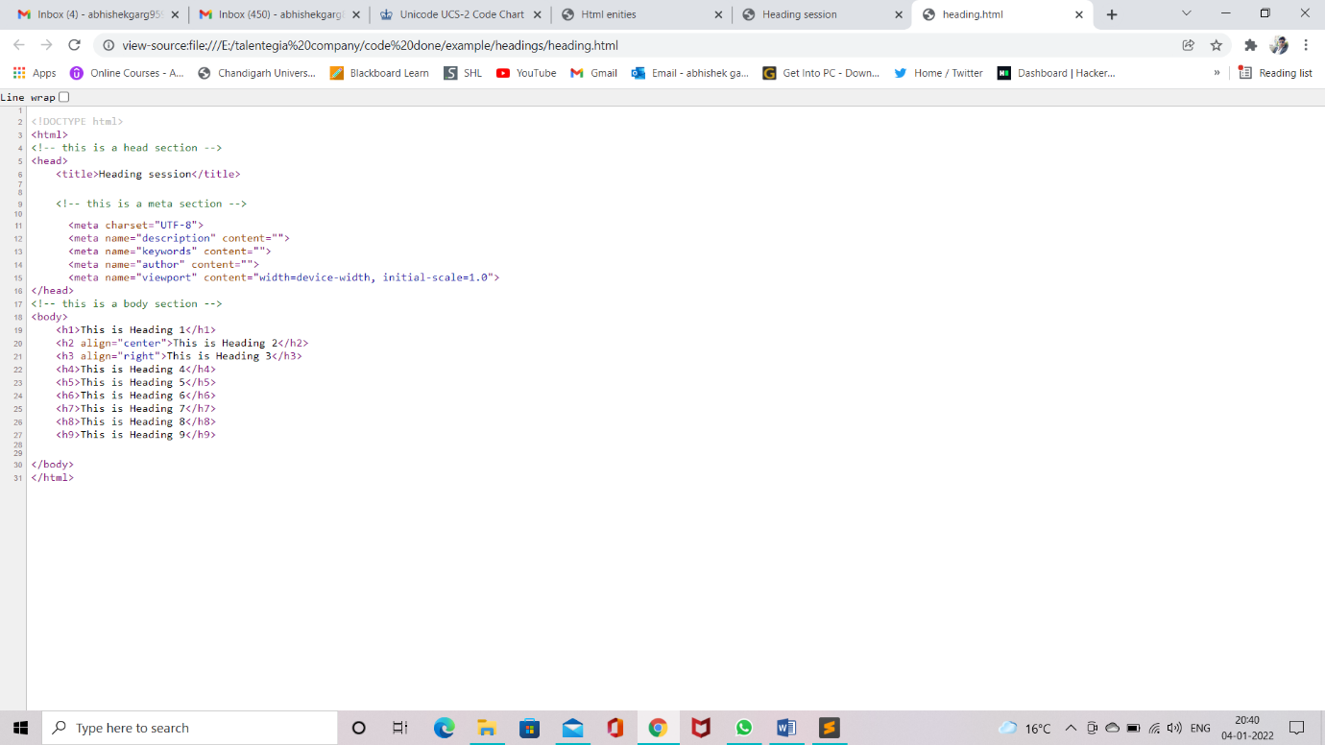

Figure 12 Heading code snip

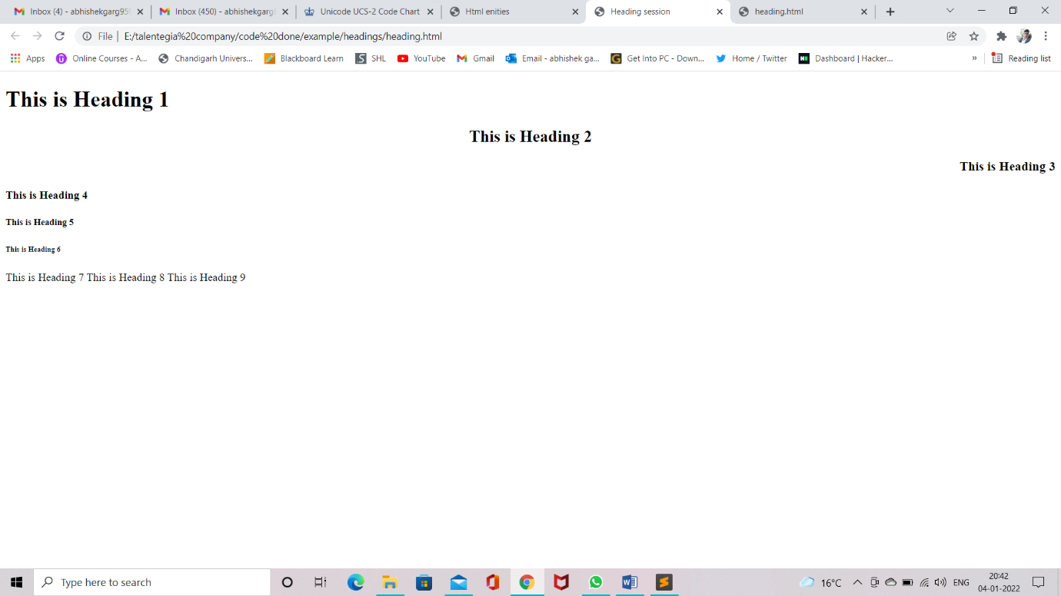

Figure 13 Heading Website view

# HTML Paragraph(<p> tag)

* It is used to divide text into different paragraphs.
* It is a paired tags.

Attributes Parameters

Align left, right,center,justify

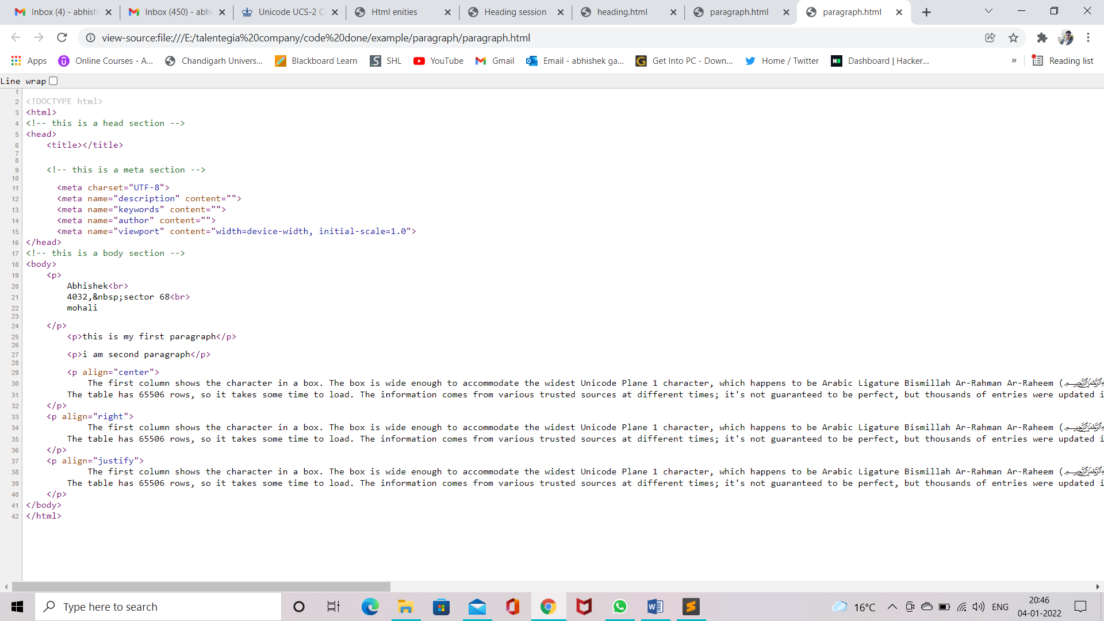

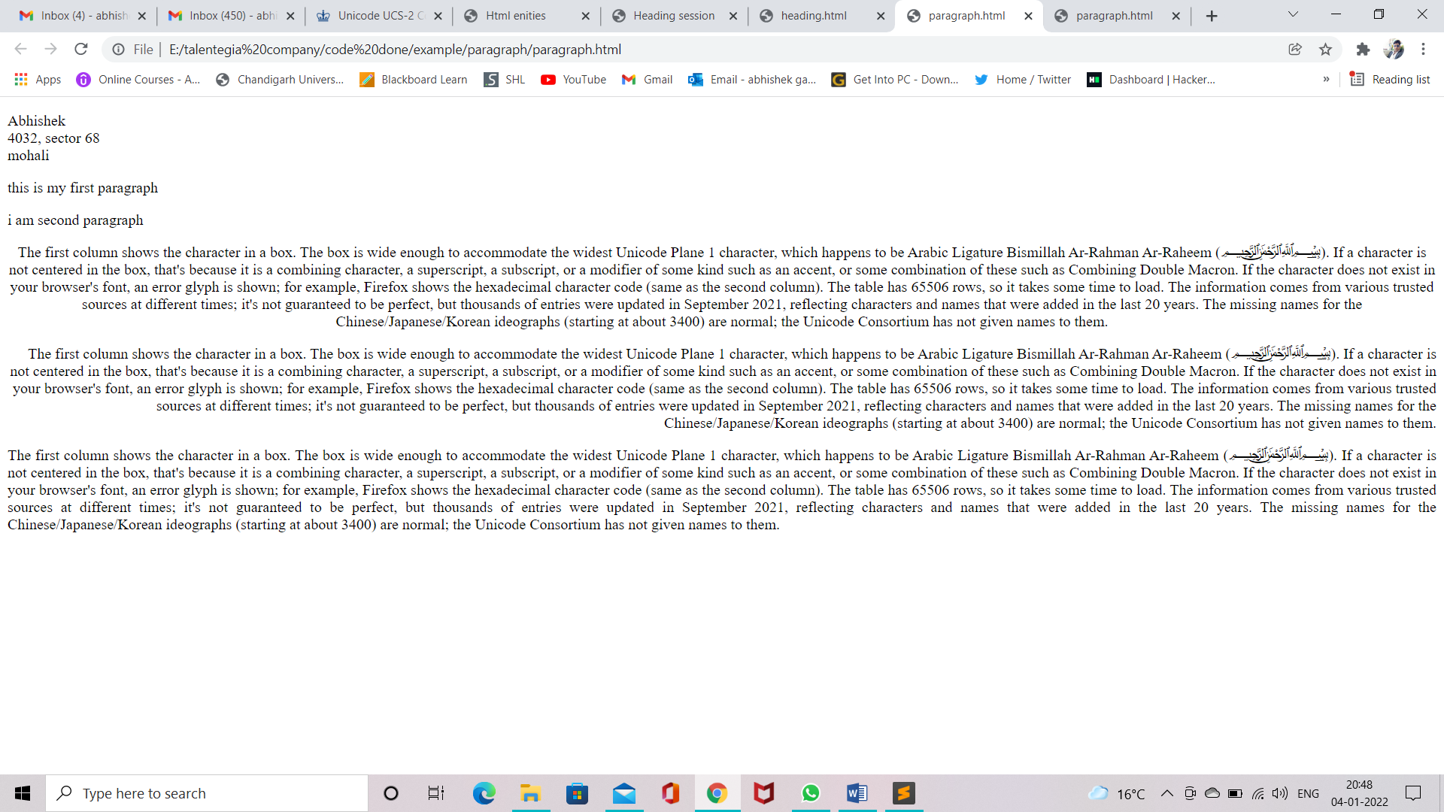

Figure 14 Paragraph web snip

Figure 15 Paragraph code

# Line Brake(<br> tag)

* <br> stands for breaks.
* It is used to break a line and shift following text to next line.
* It is a non-paired tag.

# Non-Breaking Space (&nbsp;)

* It is used to insert more than one spaces.
* It is special character entity

# HTML Horizontal rule(<hr> tag)

* This tag is used to draw a line across the web page.
* It is a non-paired tag.

Attribute Parameters

Color color name/code

Size px

Width % / px

Align left, center, right

Noshade noshade

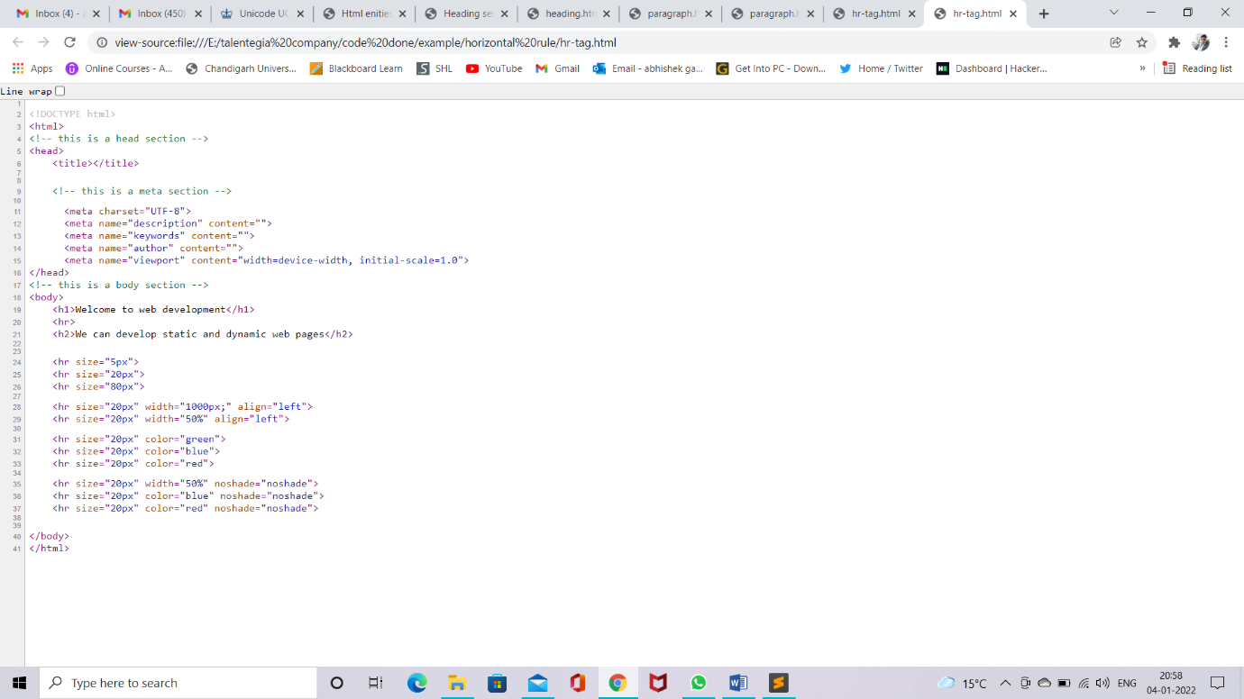Note :- Noshade is working with only noshade not with color names.

Figure 16 hr tag code

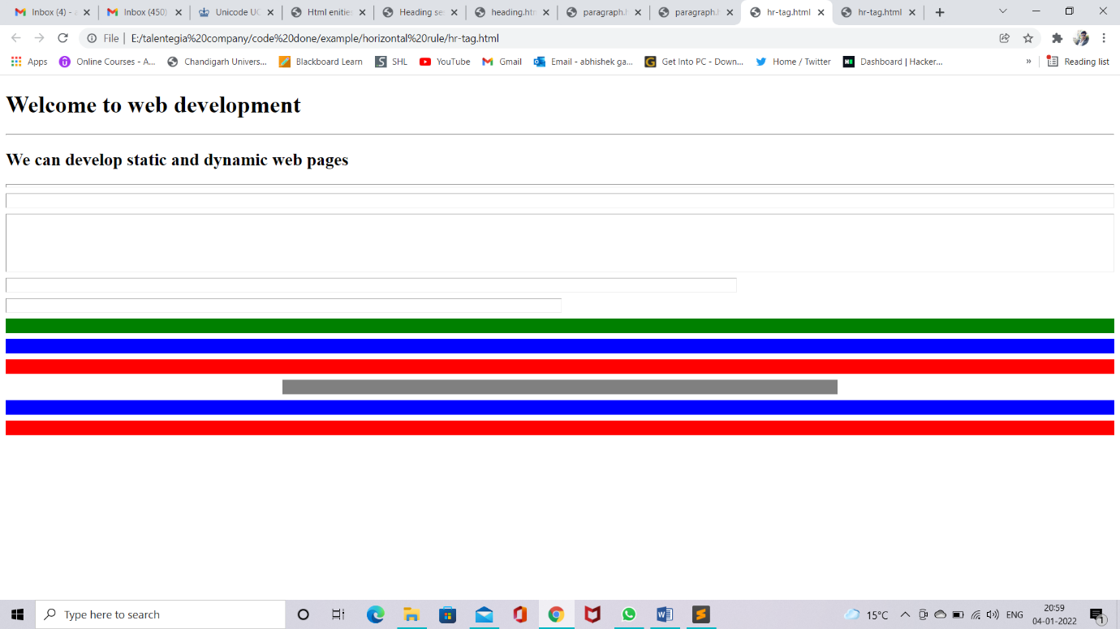

Figure 17 hr tag website snipt

# User Inputs

* To accept inputs from user, generally we use forms.

## HTML forms(<form> tag)

* This tag defines a form that is used to collect user inputs.
* It is a paired tag.
* Form Attributes
  + Method
  + Action
  + Target
  + Encrypt
* <input /> tag

Attributes Parameters

Name any name

Value any value

Size px

Max length number

Rows number

Cols number

Readonly true/false

Disabled disabled

Checked checked

Multiple true/false

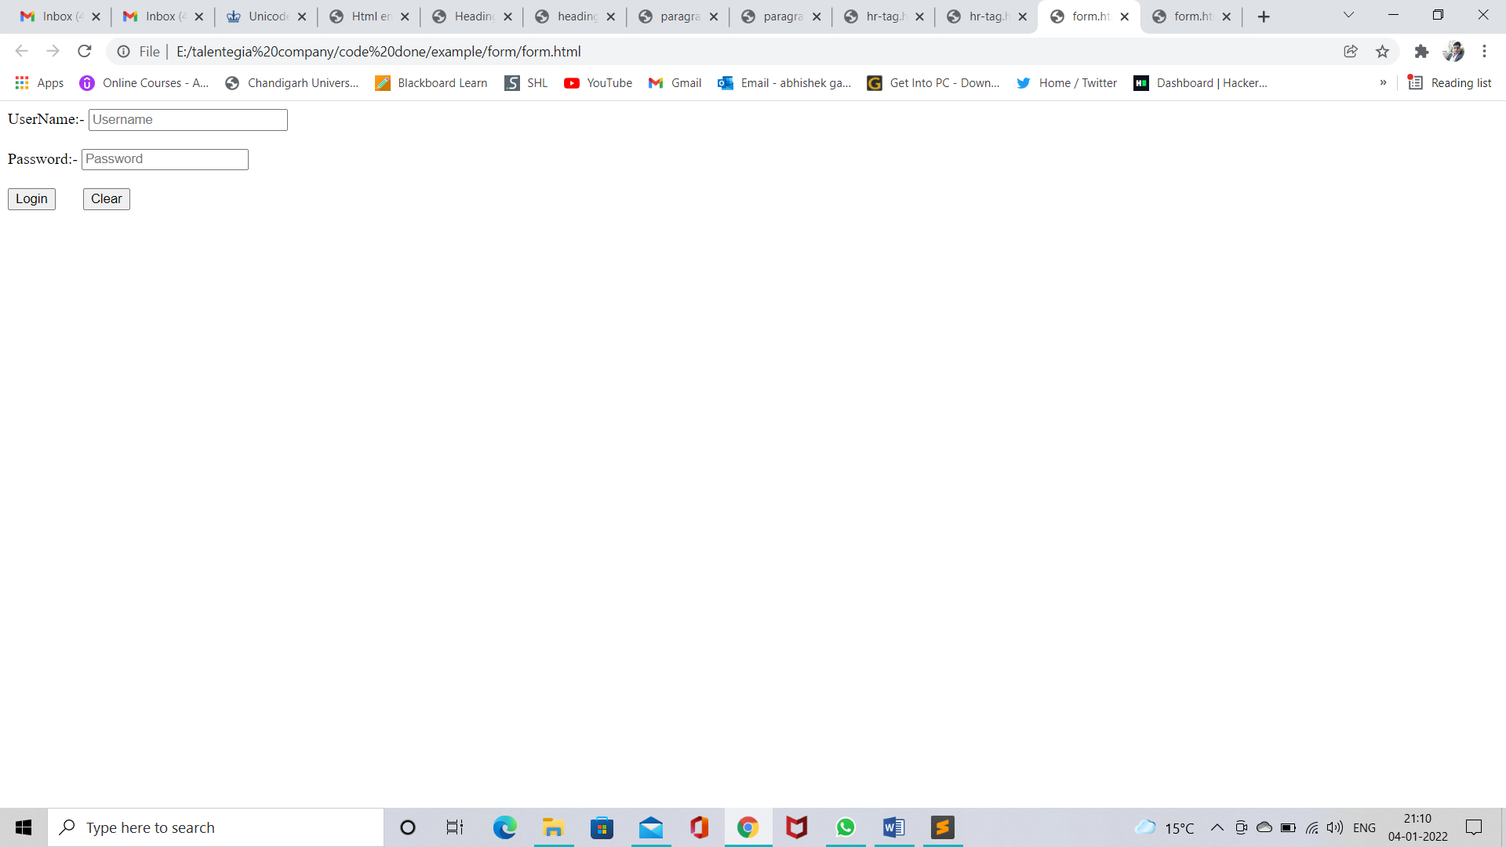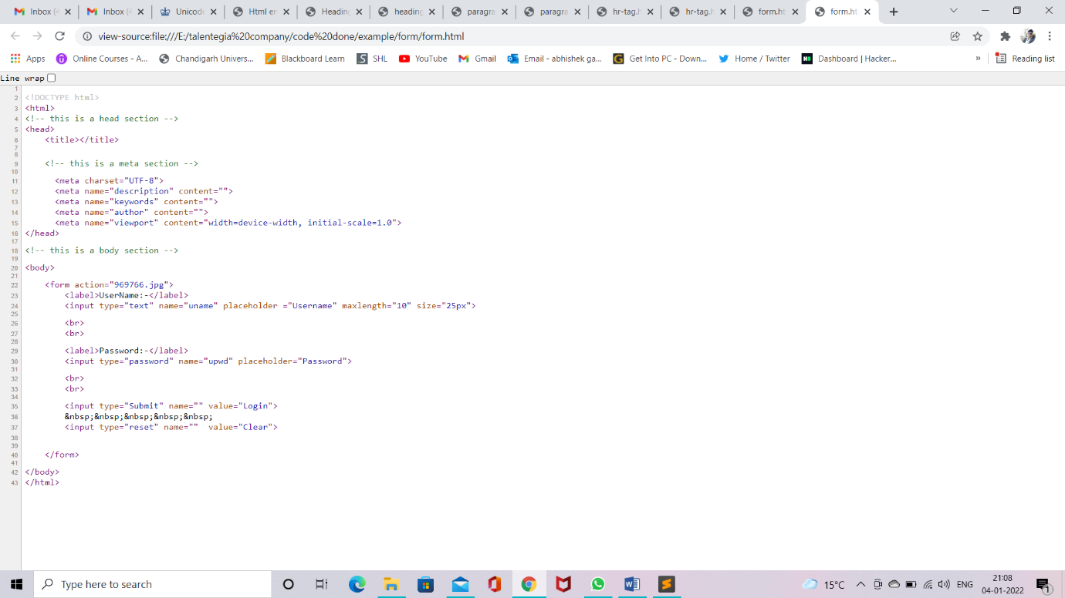

Figure 18 form web look

Figure 19 form code

# Textarea(<textarea>)

* Multiple textbox
* <textarea rows=”5” cols=”45”>…</textarea>

<!DOCTYPE html>

<html>

<!-- this is a head section -->

<head>

<title></title>

<!-- this is a meta section -->

<meta charset="UTF-8">

<meta name="description" content="">

<meta name="keywords" content="">

<meta name="author" content="">

<meta name="viewport" content="width=device-width, initial-scale=1.0">

</head>

<!-- this is a body section -->

<body>

<textarea></textarea>

<textarea rows="5" cols="45"></textarea>

<textarea rows="5" cols="45" maxlength="6"></textarea>

</body>

</html>

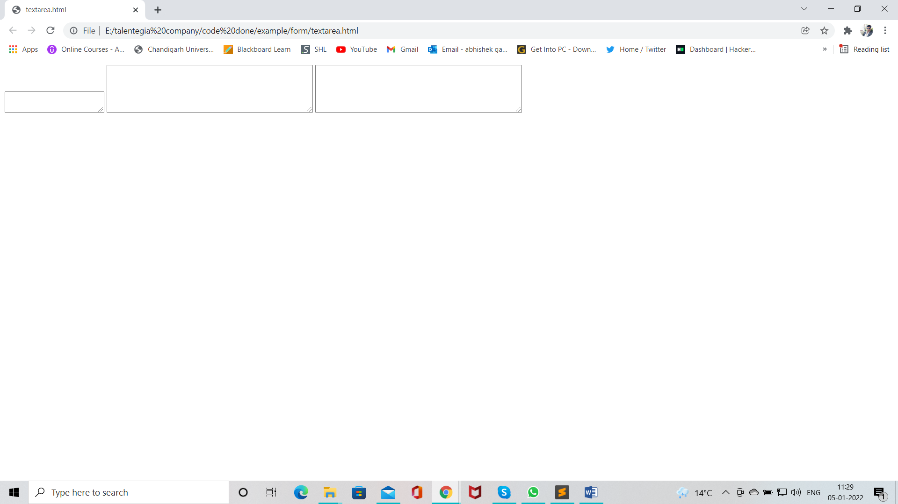

Figure 20 textarea web snipt

# Dropdown List(<select> tag)

* <select> tag is used to create dropdown list
* <option> tag inside select element define the available option in the list.
* <select> and <option> both tag are paired tag.

<select> tag

Attributes Parameters

Disabled disabled

Multiple multiple

Size number(number of visible option)

<option> tag

Attribute Parameters

Disabled disabled

Label text

Selected selected

Value text

<optgroup>tag

* It is used to group logically related option in the dropdown list
* For longlist options group of related options are easier for user to handle.

Attributes Parameters

Disabled disabled

Label text

<!DOCTYPE html>

<html>

<!-- this is a head section -->

<head>

<title></title>

<!-- this is a meta section -->

<meta charset="UTF-8">

<meta name="description" content="">

<meta name="keywords" content="">

<meta name="author" content="">

<meta name="viewport" content="width=device-width, initial-scale=1.0">

</head>

<!-- this is a body section -->

<body>

<select>

<option>Hindi</option>

<option>Punjabi</option>

<option>Haryanvi</option>

<option>English</option>

<option>Algebra</option>

<option>Geometry</option>

<option>Physics</option>

</select>

<select multiple=multiple>

<option>Hindi</option>

<option>Punjabi</option>

<option>Haryanvi</option>

<option>English</option>

<option>Algebra</option>

<option>Geometry</option>

<option>Physics</option>

</select>

<select size="5">

<option>Hindi</option>

<option>Punjabi</option>

<option>Haryanvi</option>

<option>English</option>

<option>Algebra</option>

<option>Geometry</option>

<option>Physics</option>

</select>

<select>

<option>Hindi</option>

<option>Punjabi</option>

<option>Haryanvi</option>

<option>English</option>

<option>Algebra</option>

<option>Geometry</option>

<option disabled=disabled>Physics</option>

</select>

<select>

<option>Hindi</option>

<option>Punjabi</option>

<option>Haryanvi</option>

<option selected = selected>English</option>

<option>Algebra</option>

<option>Geometry</option>

<option>Physics</option>

</select>

<select>

<option value="HN" label="Hindi_language">Hindi</option>

<option>Punjabi</option>

<option>Haryanvi</option>

<option>English</option>

<option>Algebra</option>

<option>Geometry</option>

<option>Physics</option>

</select>

<select>

<optgroup>

<option>Hindi</option>

<option>Punjabi</option>

<option>Haryanvi</option>

<option>English</option>

</optgroup>

<optgroup>

<option>Algebra</option>

<option>Geometry</option>

</optgroup>

<optgroup>

<option>Physics</option>

<option>Chemistry</option>

</optgroup>

</select>

<select>

<optgroup label="Languages">

<option>Hindi</option>

<option>Punjabi</option>

<option>Haryanvi</option>

<option>English</option>

</optgroup>

<optgroup label=Maths>

<option>Algebra</option>

<option>Geometry</option>

</optgroup>

<optgroup label="Science">

<option>Physics</option>

<option>Chemistry</option>

</optgroup>

</select>

</body>

</html>

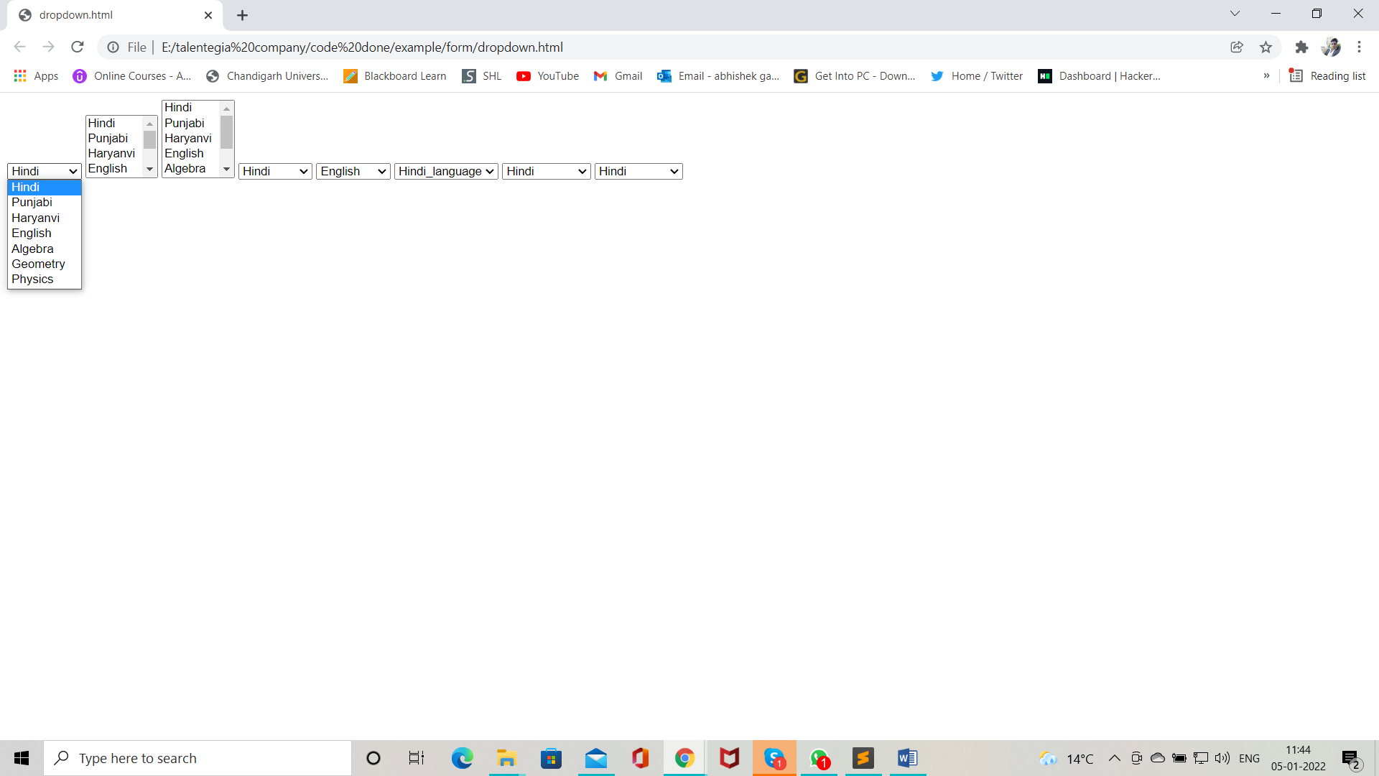

Figure 21 dropdown list web snipt

# Radio control

* Radio buttons are used when out of many options just one option required to be selected
* This are created using HTML input tag ( type = “radio” )

<!DOCTYPE html>

<html>

<!-- this is a head section -->

<head>

<title></title>

<!-- this is a meta section -->

<meta charset="UTF-8">

<meta name="description" content="">

<meta name="keywords" content="">

<meta name="author" content="">

<meta name="viewport" content="width=device-width, initial-scale=1.0">

</head>

<!-- this is a body section -->

<body>

<h1>Choose correct answer</h1>

<input type="radio" >True

<input type="radio" >False

<input type="radio" > All above

<input type="radio" >None Above

<h1>Choose correct answer</h1>

<input type="radio" name="opt">True

<input type="radio" name="opt">False

<input type="radio" name="opt1"> All above

<input type="radio" name="opt1">None Above

<h1>Choose correct answer</h1>

<input type="radio" name="opt">True

<input type="radio" name="opt">False

<input type="radio" name="opt" checked = checked> All above

<input type="radio" name="opt">None Above

<h1>Choose correct answer</h1>

<input type="radio" name="opt">True

<input type="radio" name="opt">False

<input type="radio" name="opt" checked = checked> All above

<input type="radio" name="opt">None Above

<h1>Gender</h1>

<input type="radio" name="gender">Male

<input type="radio" name="gender">Female

</body>

</html>

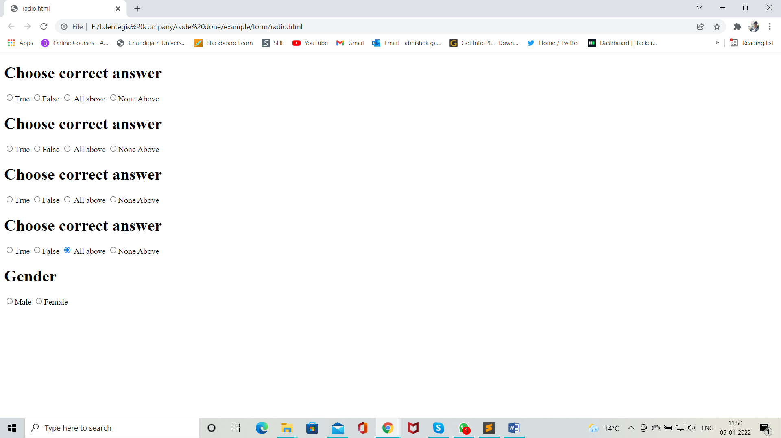

Figure 22 radio web snipt

# Checkbox

* Checkboxes are used when more than one options are required
* These are created using HTML input tag (type = “checkbox”)

<!DOCTYPE html>

<html>

<!-- this is a head section -->

<head>

<title></title>

<!-- this is a meta section -->

<meta charset="UTF-8">

<meta name="description" content="">

<meta name="keywords" content="">

<meta name="author" content="">

<meta name="viewport" content="width=device-width, initial-scale=1.0">

</head>

<!-- this is a body section -->

<body>

<h1>Choose your Hoddy / s</h1>

<input type="checkbox" name="chess">Chess

<input type="checkbox" name="Songs">Songs

<input type="checkbox" name="Reading">Readings

<input type="checkbox" name="Motivation">Motivation

<input type="checkbox" name="Travilling">Traviling

<input type="checkbox" name="dancing">Dancing

<input type="checkbox" name="cooking">cooking

</body>

</html>

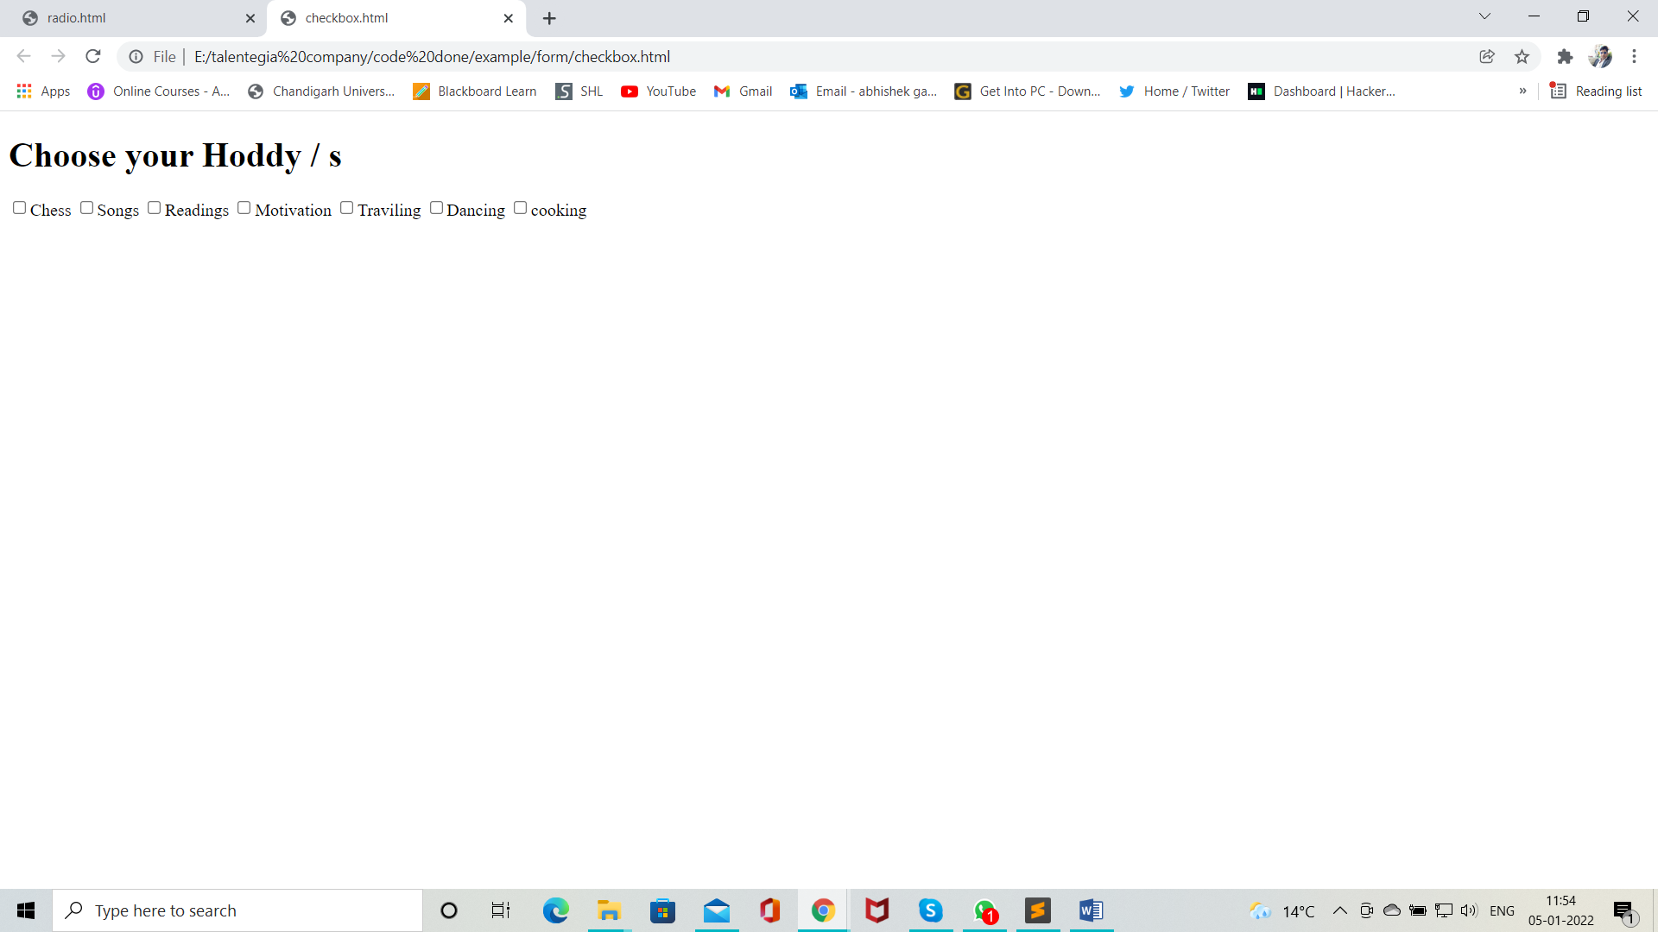

Figure 23 checkbox web snipt

# <Fieldset>

* It defines group of logically related elements
* Elements are grouped inside a box
* It is a paired tag

# <legend>

* It is used with field set to give title to each set of fields
* It is a paired tag.

Attributes Parameters

Align right, left, center

<!DOCTYPE html>

<html>

<!-- this is a head section -->

<head>

<title></title>

<!-- this is a meta section -->

<meta charset="UTF-8">

<meta name="description" content="">

<meta name="keywords" content="">

<meta name="author" content="">

<meta name="viewport" content="width=device-width, initial-scale=1.0">

</head>

<!-- this is a body section -->

<body>

<h1>Welcome to my Traveling co.</h1>

<fieldset>

<label> -: Personal Information :- </label>

<br>

<label>First Name :-</label>

<input type="text">

<br><br>

<label>Last Name :-</label>

<input type="text">

<br><br>

</fieldset>

<br><br>

<fieldset>

<input type="radio" name="tr">Road

<input type="radio" name="tr">rail

<input type="radio" name="tr">Air

<input type="radio" name="tr">Water

<br><br>

</fieldset>

<br><br>

<fieldset>

<input type="checkbox" name="lunch">Lunch

<input type="checkbox" name="water">Brinking water

<input type="checkbox" name="Fruits">Fruits

<input type="checkbox" name="Chocklet">Chocklet

</fieldset>

<br><br>

<h1>Welcome to my Traveling co.</h1>

<fieldset>

<legend> -: Personal Information :- </legend>

<br>

<label>First Name :-</label>

<input type="text">

<br><br>

<label>Last Name :-</label>

<input type="text">

<br><br>

</fieldset>

<br><br>

<fieldset>

<legend> -: mode of transport :-</legend>

<input type="radio" name="tr">Road

<input type="radio" name="tr">rail

<input type="radio" name="tr">Air

<input type="radio" name="tr">Water

<br><br>

</fieldset>

<br><br>

<fieldset>

<legend> :- Amenities required :- </legend>

<input type="checkbox" name="lunch">Lunch

<input type="checkbox" name="water">Brinking water

<input type="checkbox" name="Fruits">Fruits

<input type="checkbox" name="Chocklet">Chocklet

</fieldset>

<br><br>

<h1>Welcome to my Traveling co.</h1>

<fieldset>

<legend align="left"> -: Personal Information :- </legend>

<br>

<label>First Name :-</label>

<input type="text">

<br><br>

<label>Last Name :-</label>

<input type="text">

<br><br>

</fieldset>

<br><br>

<fieldset>

<legend align="center"> -: mode of transport :-</legend>

<input type="radio" name="tr">Road

<input type="radio" name="tr">rail

<input type="radio" name="tr">Air

<input type="radio" name="tr">Water

</fieldset>

<br><br>

<fieldset>

<legend align = "right"> :- Amenities required :- </legend>

<input type="checkbox" name="lunch">Lunch

<input type="checkbox" name="water">Brinking water

<input type="checkbox" name="Fruits">Fruits

<input type="checkbox" name="Chocklet">Chocklet

</fieldset>

</body>

</html>

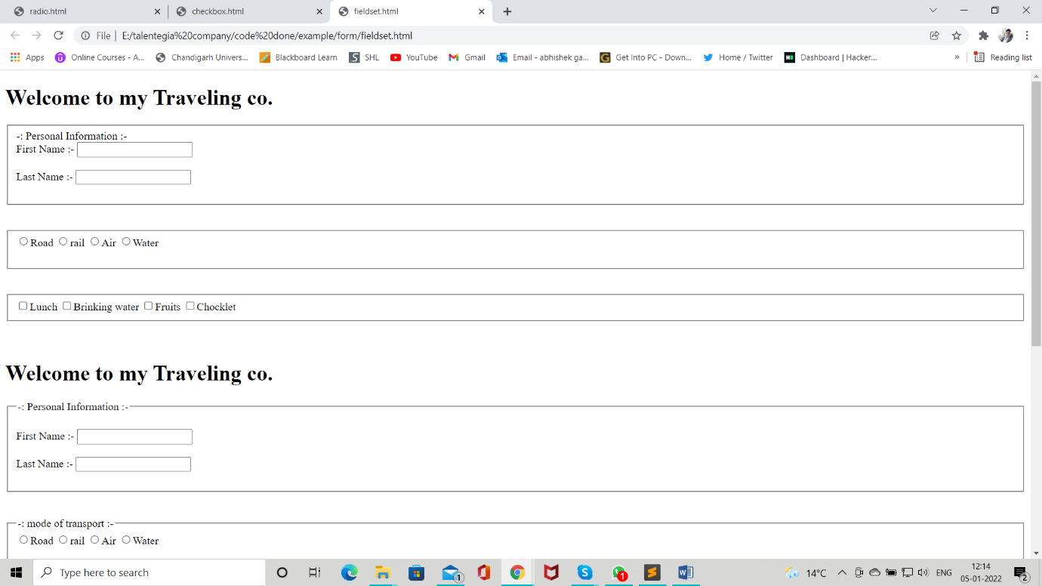

Figure 24 Legend and Fieldset web sinpt 1

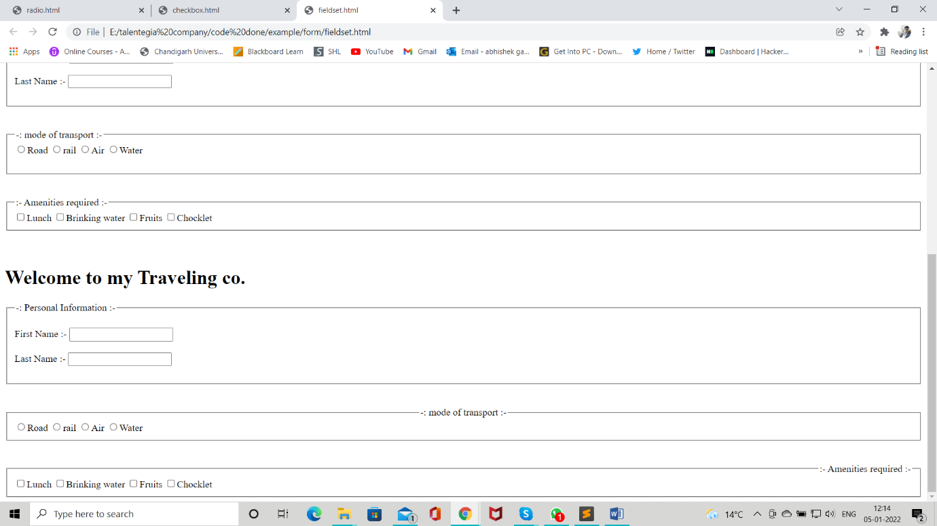

Figure 25 Legend and Fieldset web sinpt 2

# HTTP ( Hypertext Transfer Protocol )

* It is used to enable/establish communication between client and server
* HTTP works as request-response protocol between client and server
* A web browser is client
* The computer who hosts the website is server

## HTTP request methods

* There are various methods of HTTP requests
* E.g. GET, POST, PUT, UPDATE, DELETE, CONNECT, … etc.
* Of which two methods are commonly used for request – response between client and server.
  + Get
  + Post

## Action Attribute

* This attribute is used to specify url of the server page to which we want to send our form data.

### Get Methods

* In this methods there is no security for data.
* This methods can send only limited data(2MB)
* It can carry row data from client to server.

<!DOCTYPE html>

<html>

<!-- this is a head section -->

<head>

<title></title>

<!-- this is a meta section -->

<meta charset="UTF-8">

<meta name="description" content="">

<meta name="keywords" content="">

<meta name="author" content="">

<meta name="viewport" content="width=device-width, initial-scale=1.0">

</head>

<!-- this is a body section -->

<body>

<!-- in action if we want to go google chrome then we have to fill all data like https://www.goggle.com -->

<form method="GET" action="969766.jpg" name="my_form">

<label>Username :-</label>&nbsp;&nbsp;&nbsp;&nbsp;

<input type="text" name="uname" placeholder="Enter Username">

<br><br>

<label>Password :-</label>&nbsp;&nbsp;&nbsp;&nbsp;

<input type="password" name="upwd" placeholder="Enter Password">

<br><br>

<input type="Submit" name="" value="Login">&nbsp;&nbsp;&nbsp;&nbsp;

<input type="Reset" name="" value="Clear">

</form>

</body>

</html>

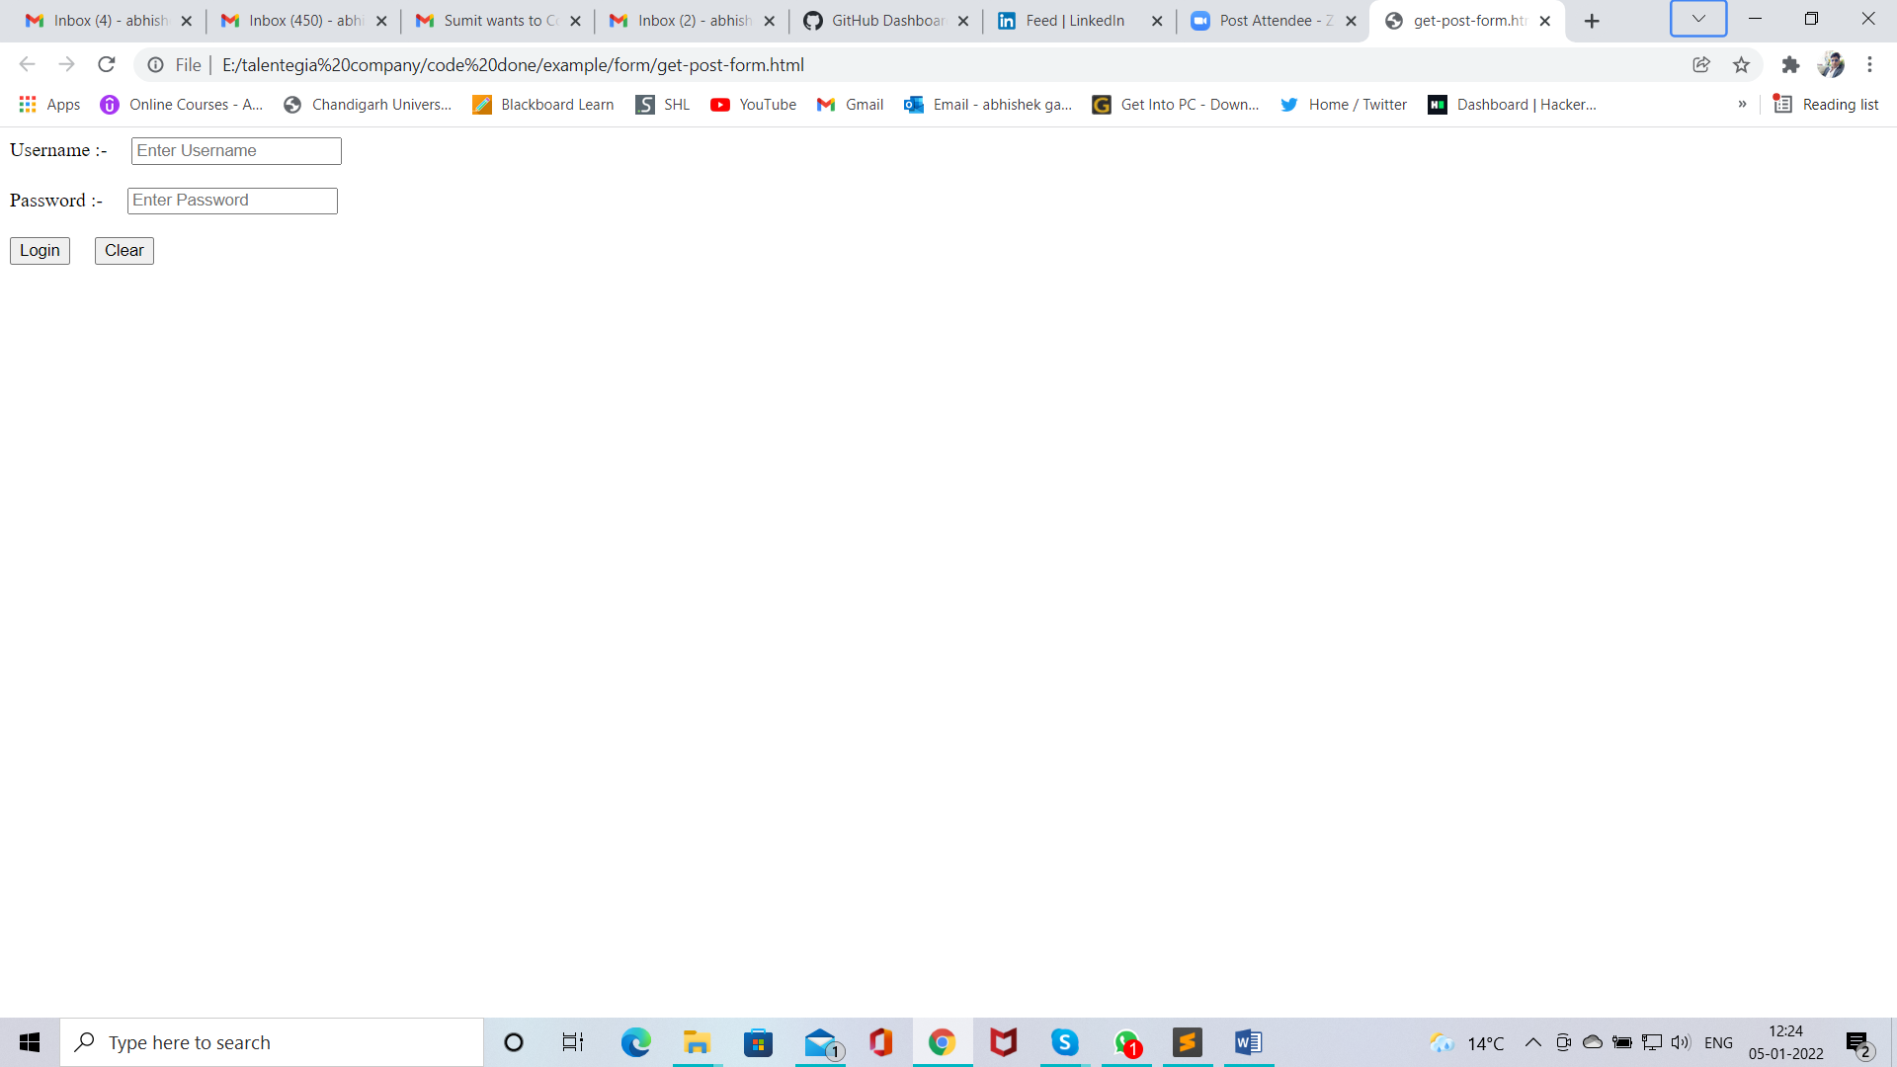

Figure 26 get web snipt 1

